**Employee management system**

**(overview)**

WHAT:

1.It is a data management application which can manage data of employees(personal details,employment history and other records).

2.It provides features such as view count of employees, a specific employee ,add new employee, delete old employee.

3.It also provides feature of attendance tracking, payroll management, employee performance.

4.This Application uses Mysql as a DBMS.

5.This Application is a web Application which can run on Local area network.

WHY:

1.This project is very useful for corporate companies, **Small and Medium Enterprises (SMEs),** Educational institues, healthcare organizations,construction and engineering firms,and other employee related organizations.

2.This kind of project develops your programming skills, data management skills, project management skills .

HOW:

Backend: MySQL, SQL, Python.

Frontend: Streamlit.

|  |  |  |  |  |  |  |  |
| --- | --- | --- | --- | --- | --- | --- | --- |
| Employee | Depart  ment | role | attendance | payroll | Performance table |  | Employee  _  Roles table |
| e_id | Dept_  id | Role  _id | attendance  _id | Payroll  _id | Performance_id |  |  |
| First  _name | Dept  _name | Role  _name | e_id | e_id | E_id |  |  |
| Last  _name |  |  | month | month | Review_date |  |  |
| email |  |  | status | salary | rating |  |  |
| Phone  _no |  |  |  | bonus | comments |  |  |
| Hiredate |  |  |  | Deduc  tions |  |  |  |
| address |  |  |  |  |  |  |  |
| Depart  ment_id |  |  |  |  |  |  |  |

**Database structure**

**MySQL with python connectivity and features development**

1.creating a virtual environment

2.activating the virtual environment

3.installation of packages in virtual environment

4.connecting mysql to python

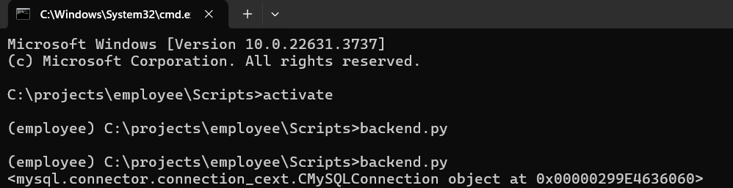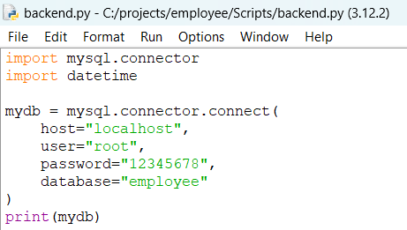

5.To insert data from database(user can insert data)

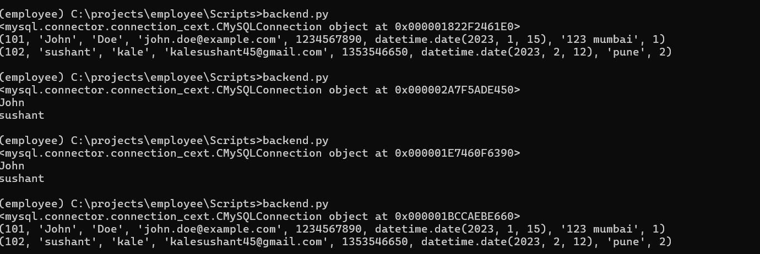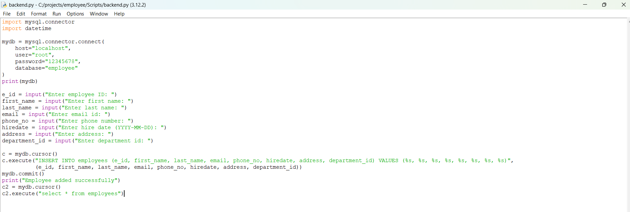

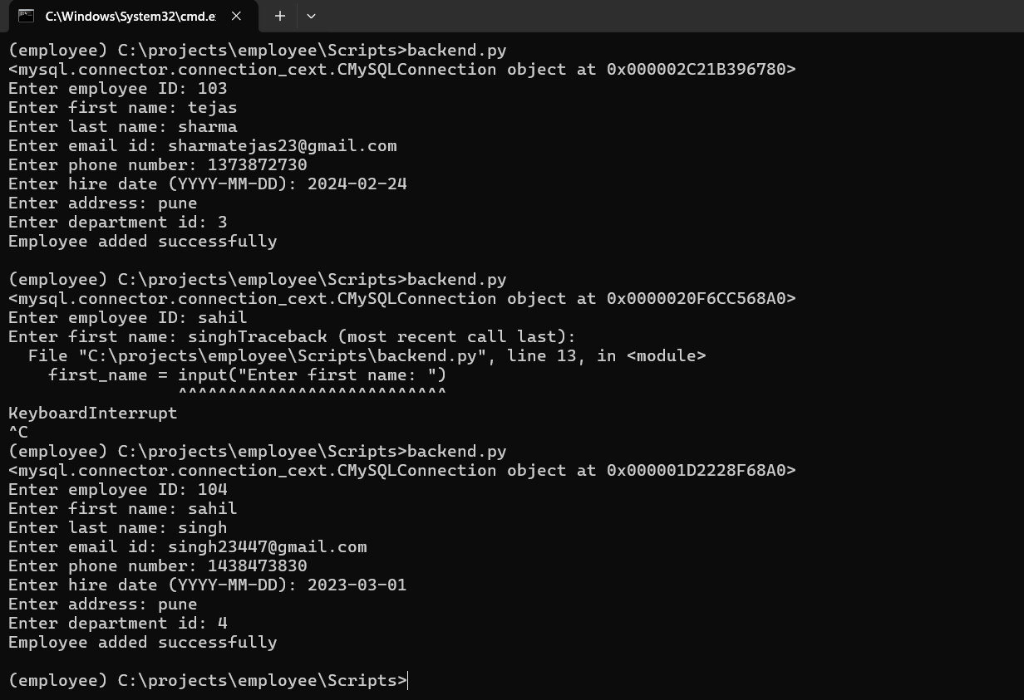

**Frontend development**

steps:

1.installing streamlit in virtual environment

2.importing streamlit in python code

3.printing title,adding images ,adding videos

4.enabling a drop down menu and giving a choice to control

5.thus adding employee login page

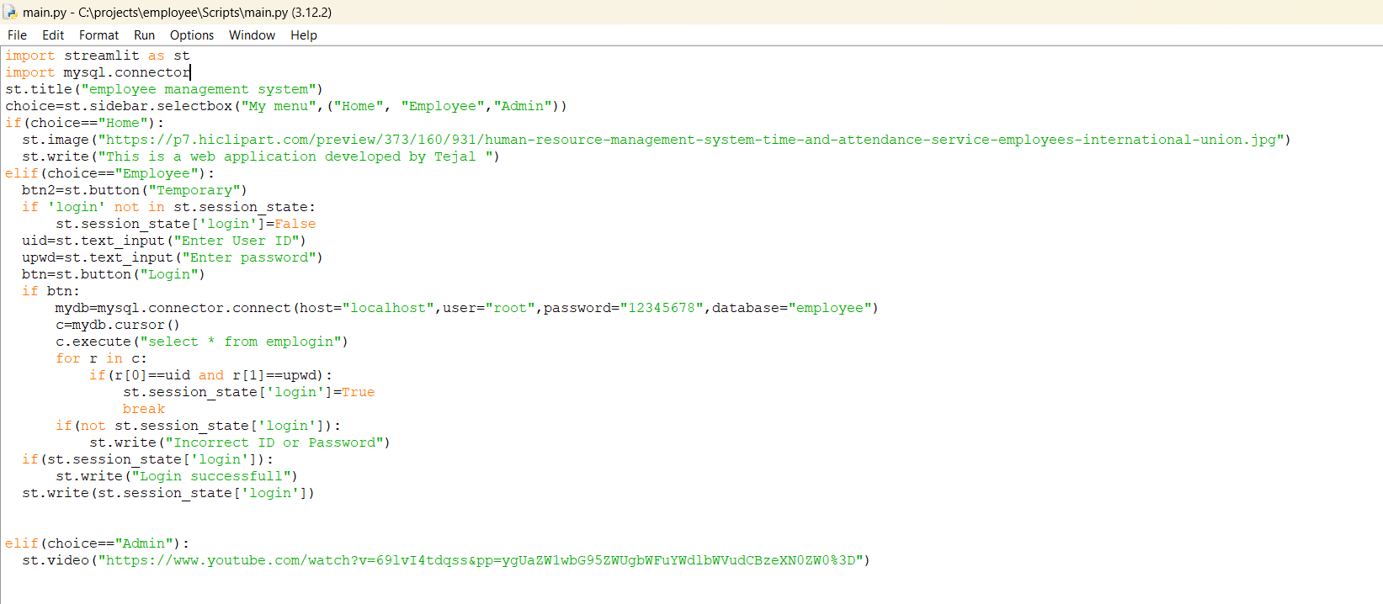

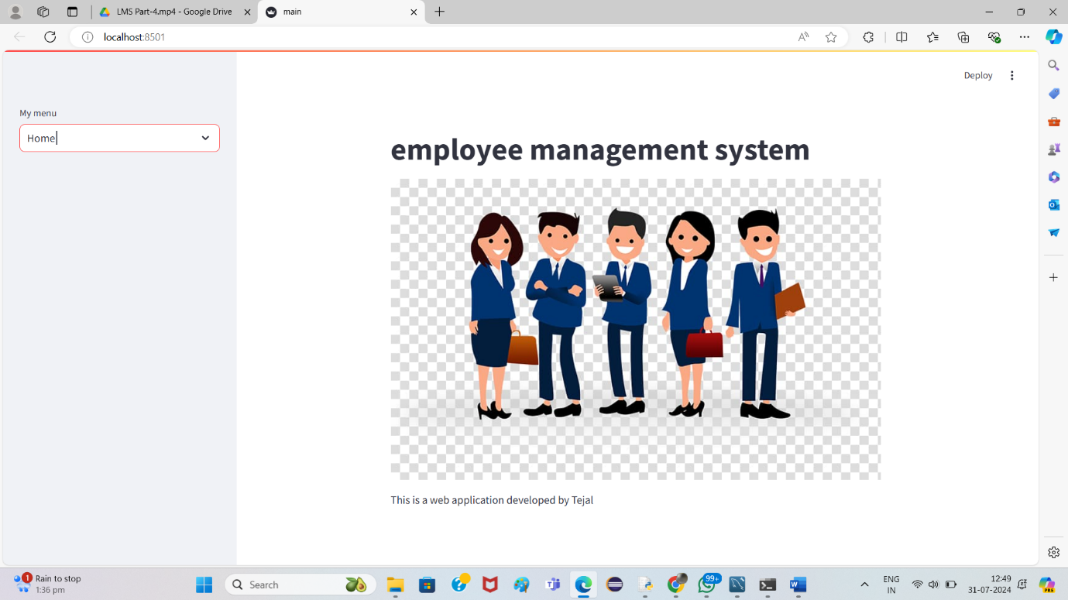

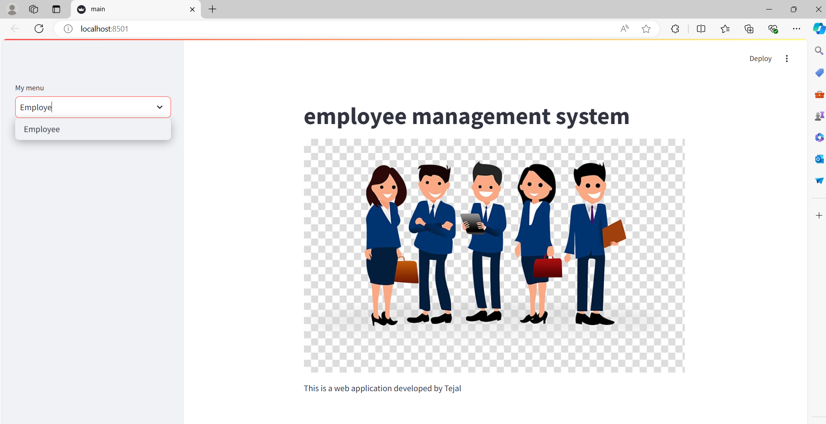

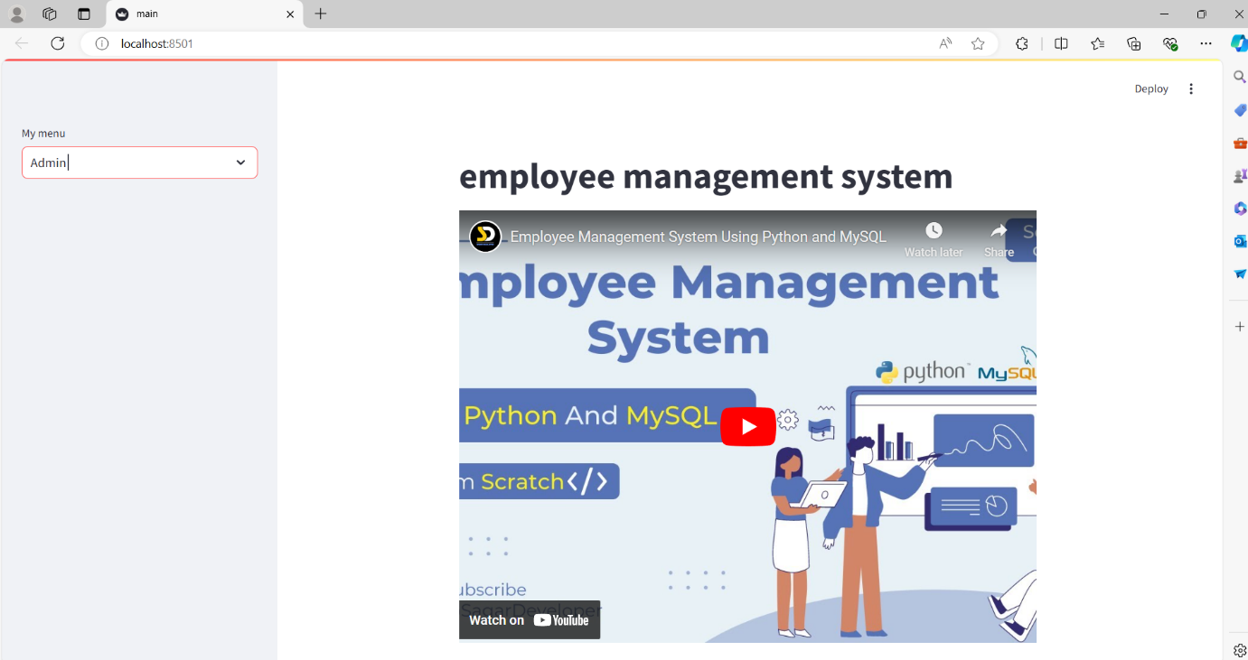

**Feature Integration in Frontend development**

1.I have created the menu bar as home ,employee,admin

2.The admin can add employee,delete employee, check payroll,check attendance,etc.

1.if choice==employee,view all employees

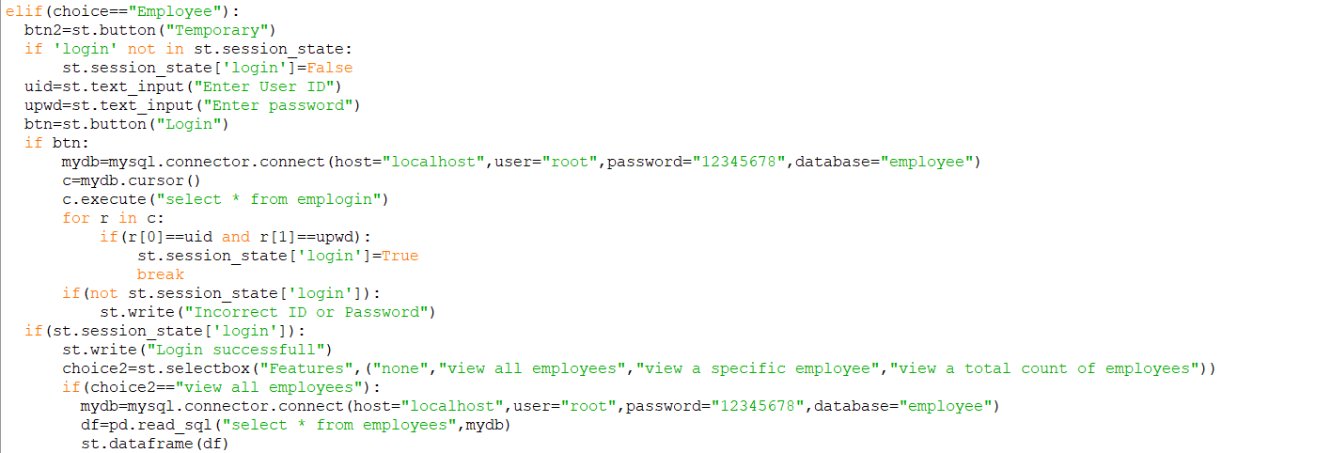

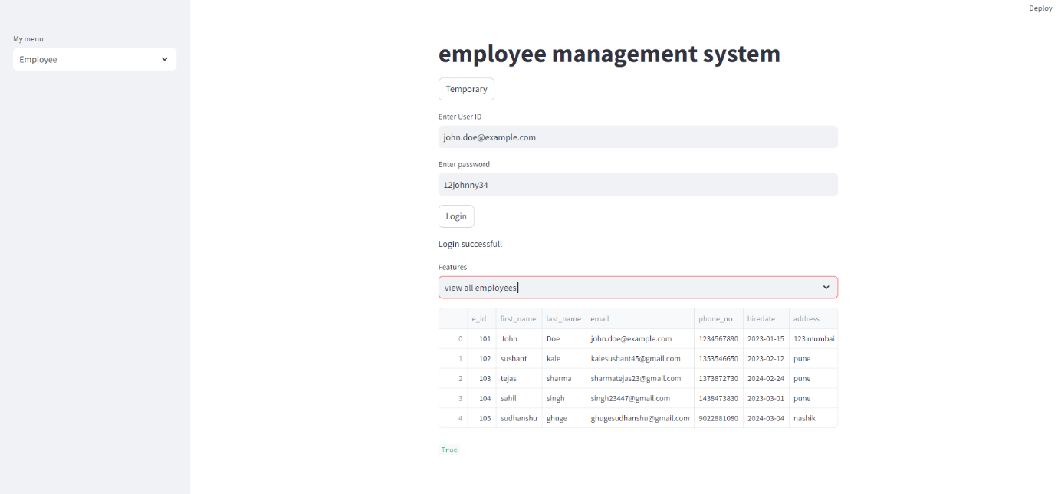

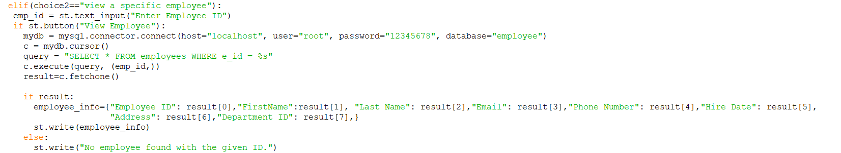2.If choice==employee,view a specific employee

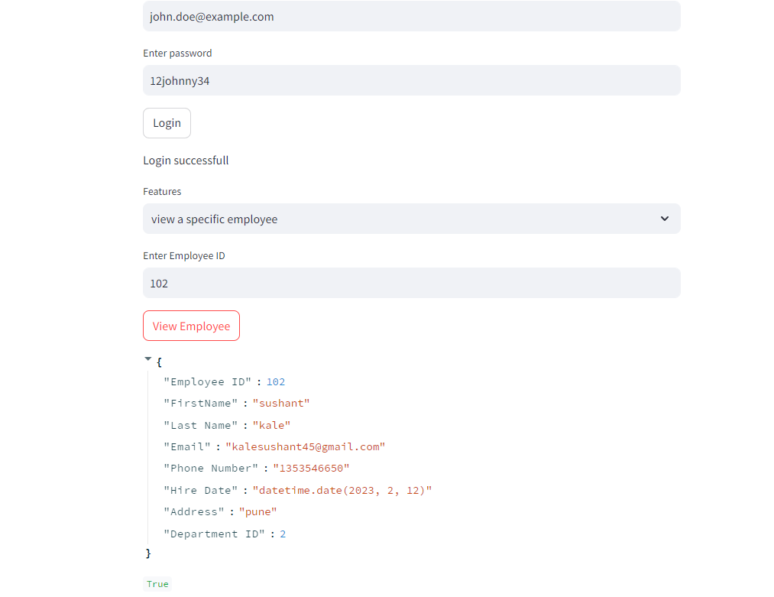

3.if choice==employee,view count of employees

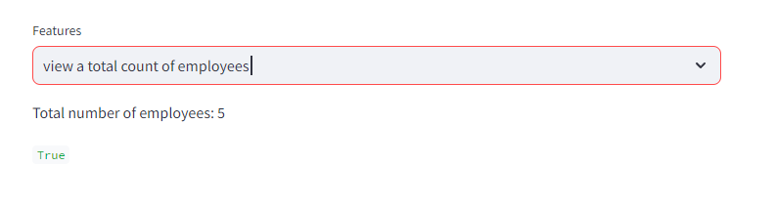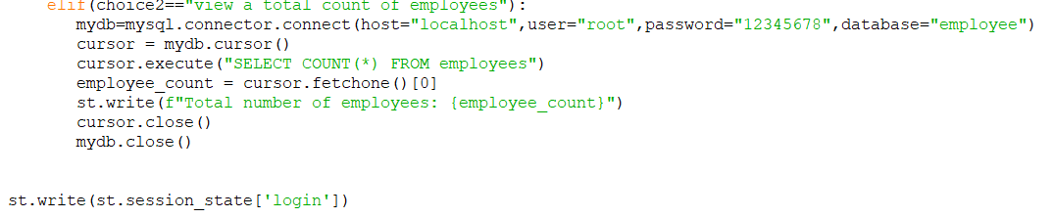

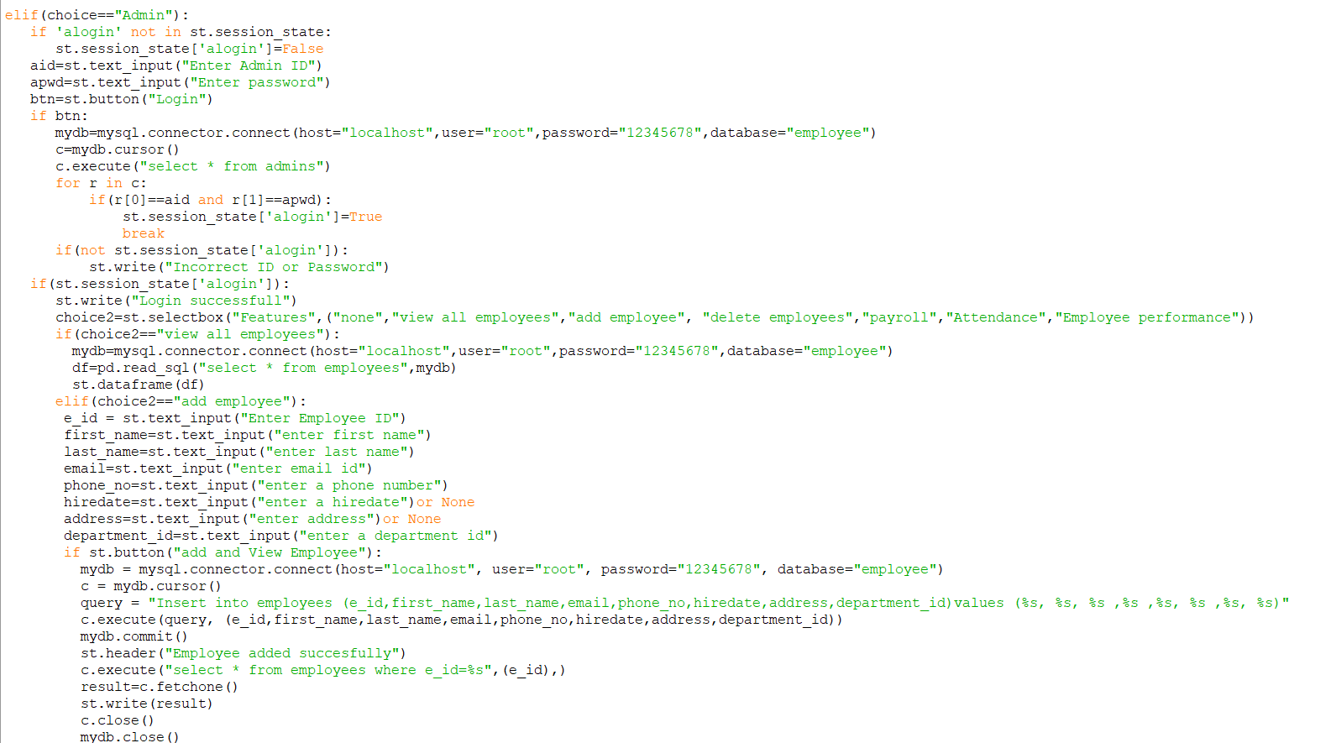 4.if choice==admin

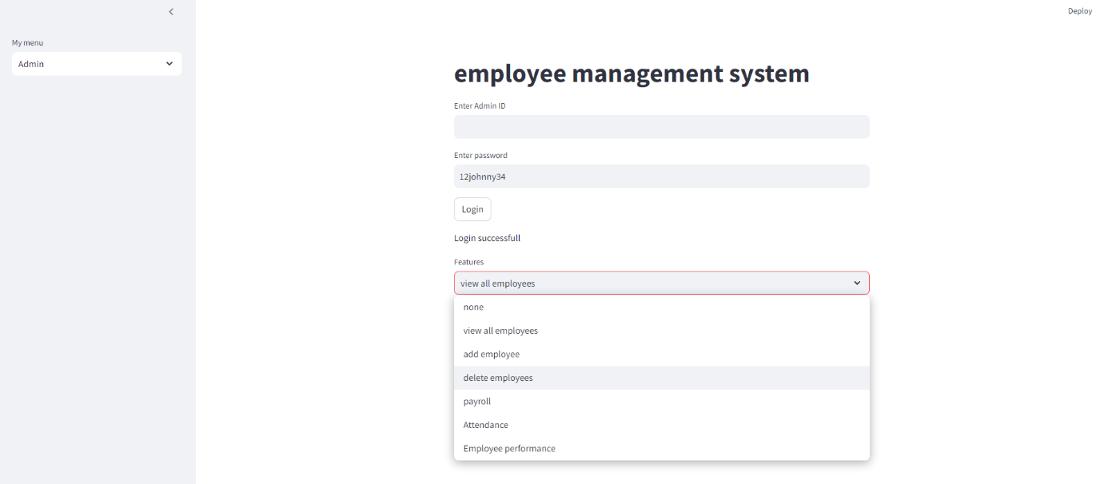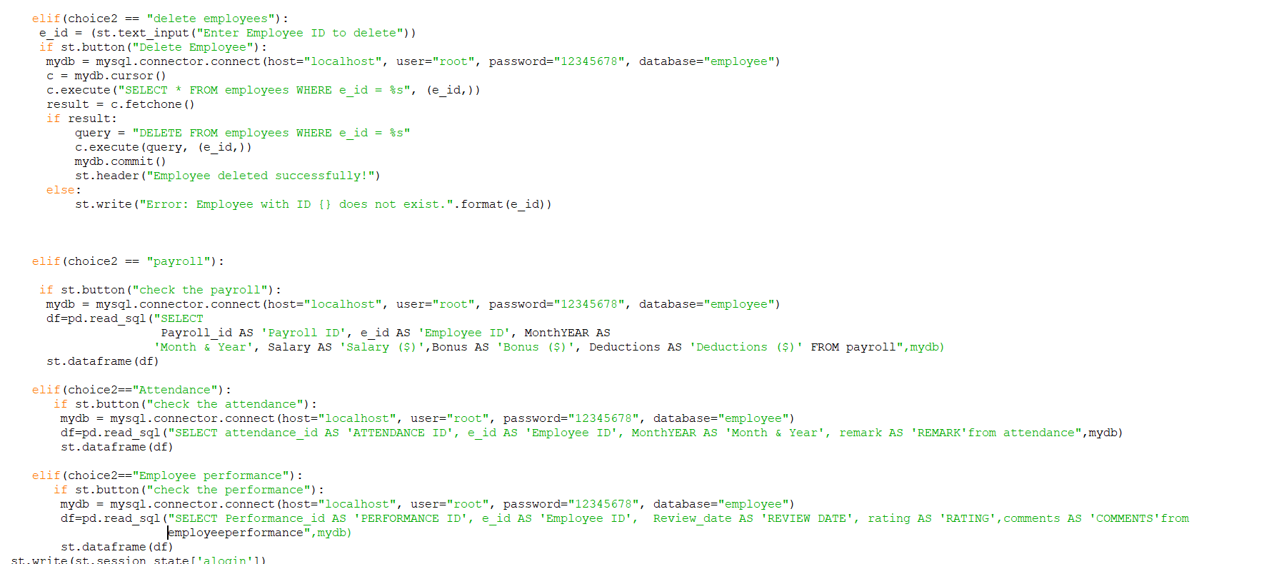

output:

